

Ashville Surgery Patient Participation Group NOTES & ACTIONS
Thursday 27 AUGUST 2026, 17.00-18.00 (in person and via MS Teams)

Present: | In attendance:
Mary ASHBY (in person) | Magnus NELSON, Practice Manager, Ashville
Greta CHAFFER (in person) | Linh HA, Practice Manager, Ashville
Anza CLARKE (in person) | Lesley HUNTING, Notes Summariser, Ashville
Rob COOPER (Teams) | Kirsty KRELLE, Paramedic, SF PCN
Mody KREITMAN (Teams) | Jennie BEACH, GP, Ashville
Sandra SMITH GORDON (Teams)
Apologies:
Heather PONTIFEX
Kenneth WEST
1 Welcome and introductions
- MN welcomed all to the meeting, and asked everyone to introduce themselves as there were new members of the group (Mary and Greta) and Linh – our new practice manager.
2 Matters arising from 18 JUNE 2026 meeting
- PPG membership. This was discussed at the last meeting and remains a focus for Ashville as we need to try and expand membership of the group to ensure we have a range of views and representation at meetings. We will continue trying to recruit new members.
3 PCN developments
- Paramedic service presentation – Kirsty KRELLE
Kirsty gave an overview of Paramedic service, which is managed by the PCN, with paramedics providing clinics in practices across the network. Below is a summary of Kirsty’s presentation.

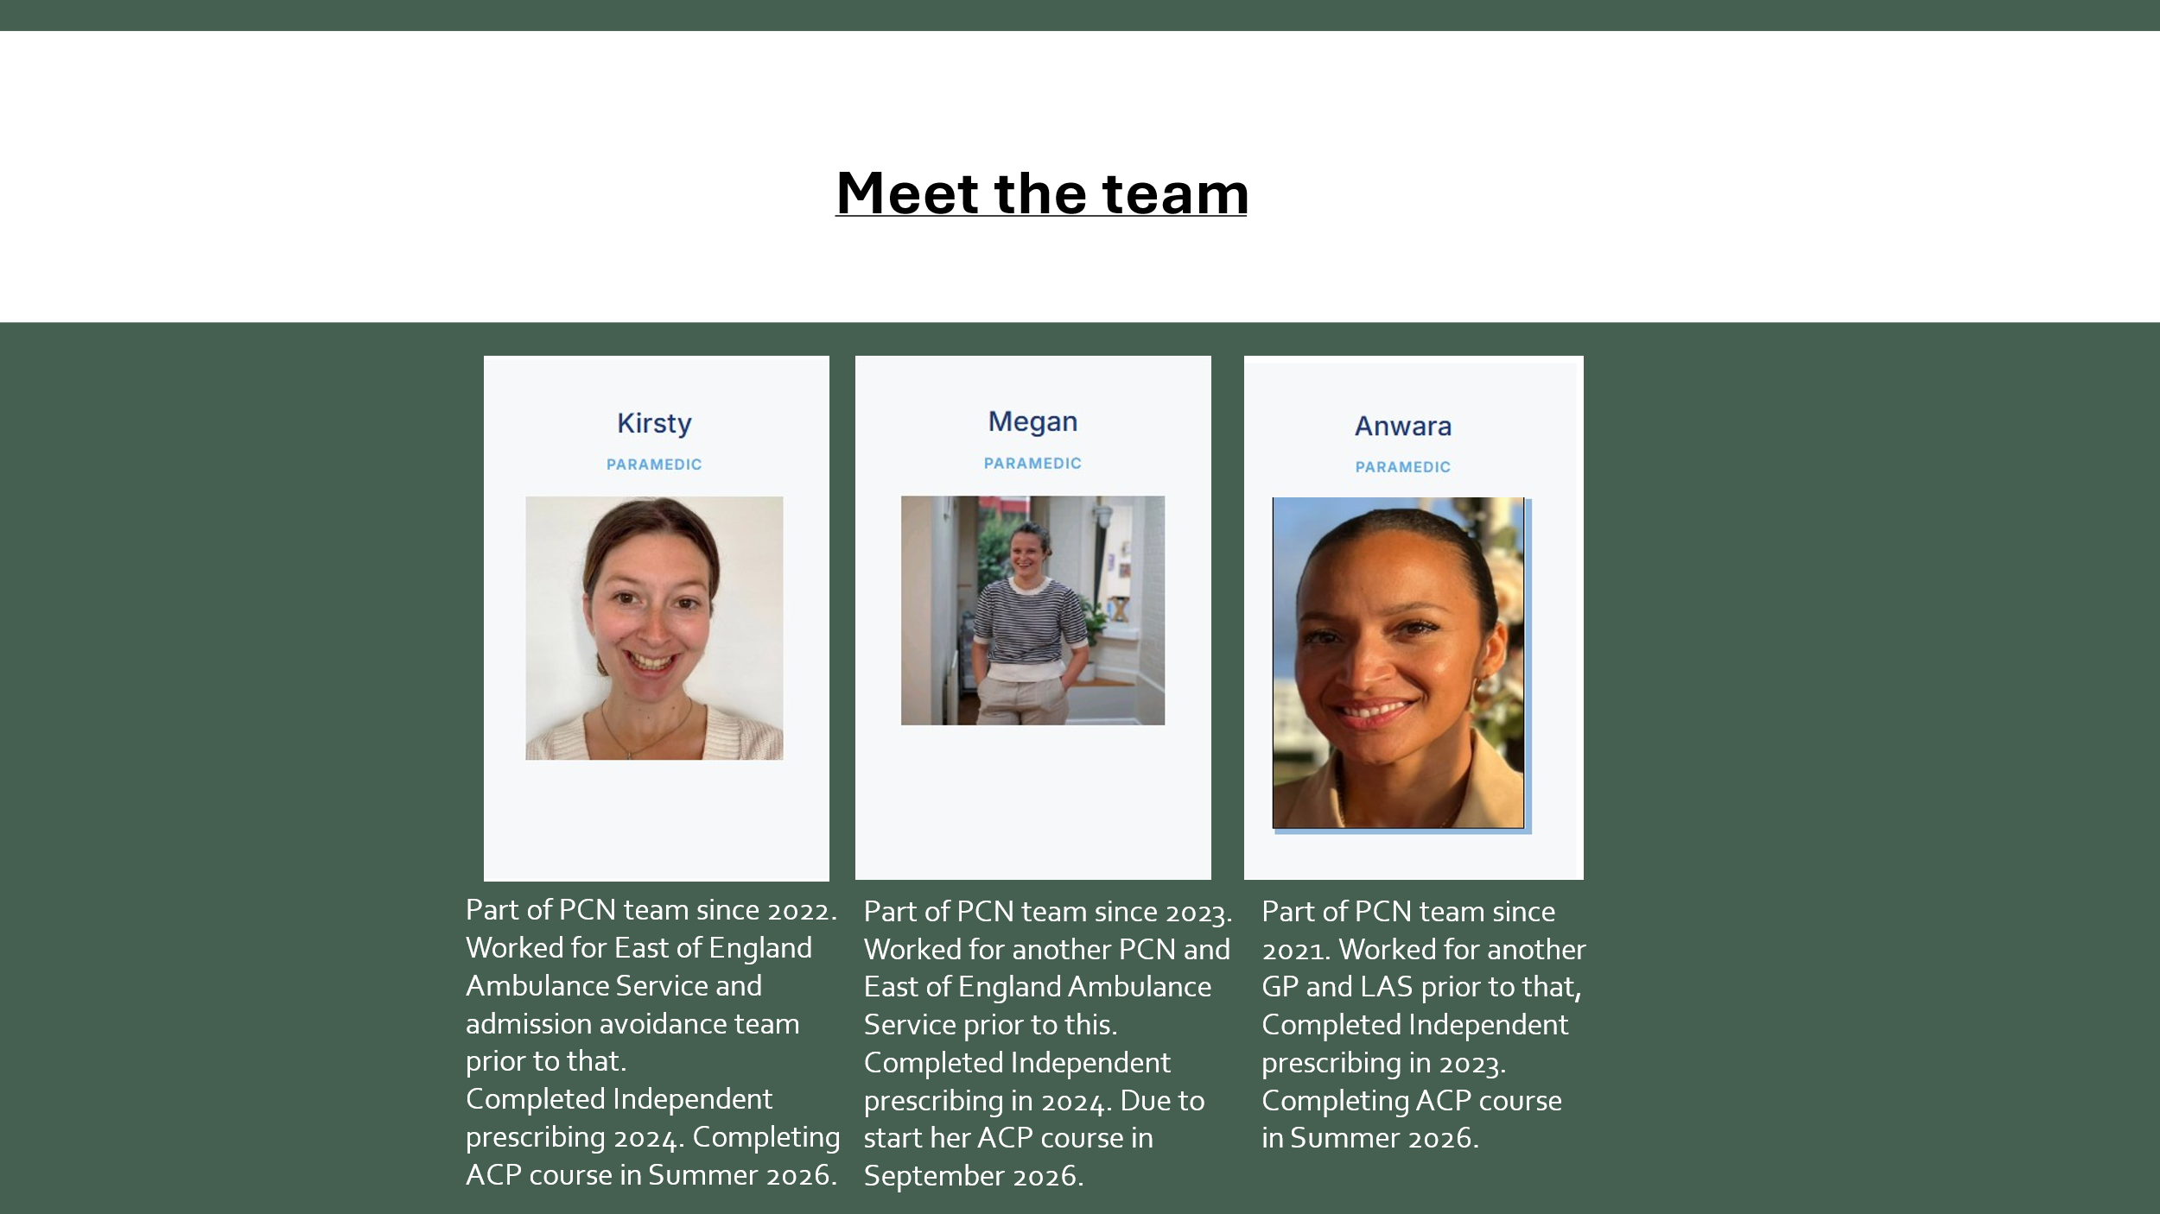
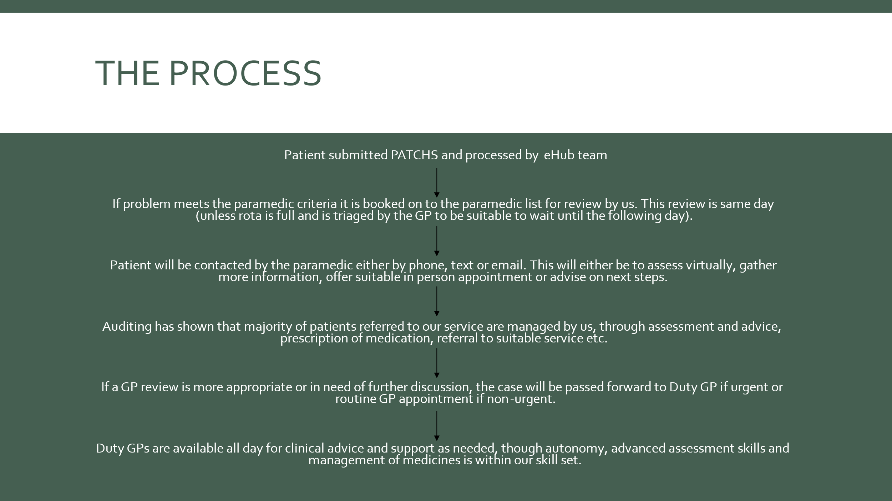
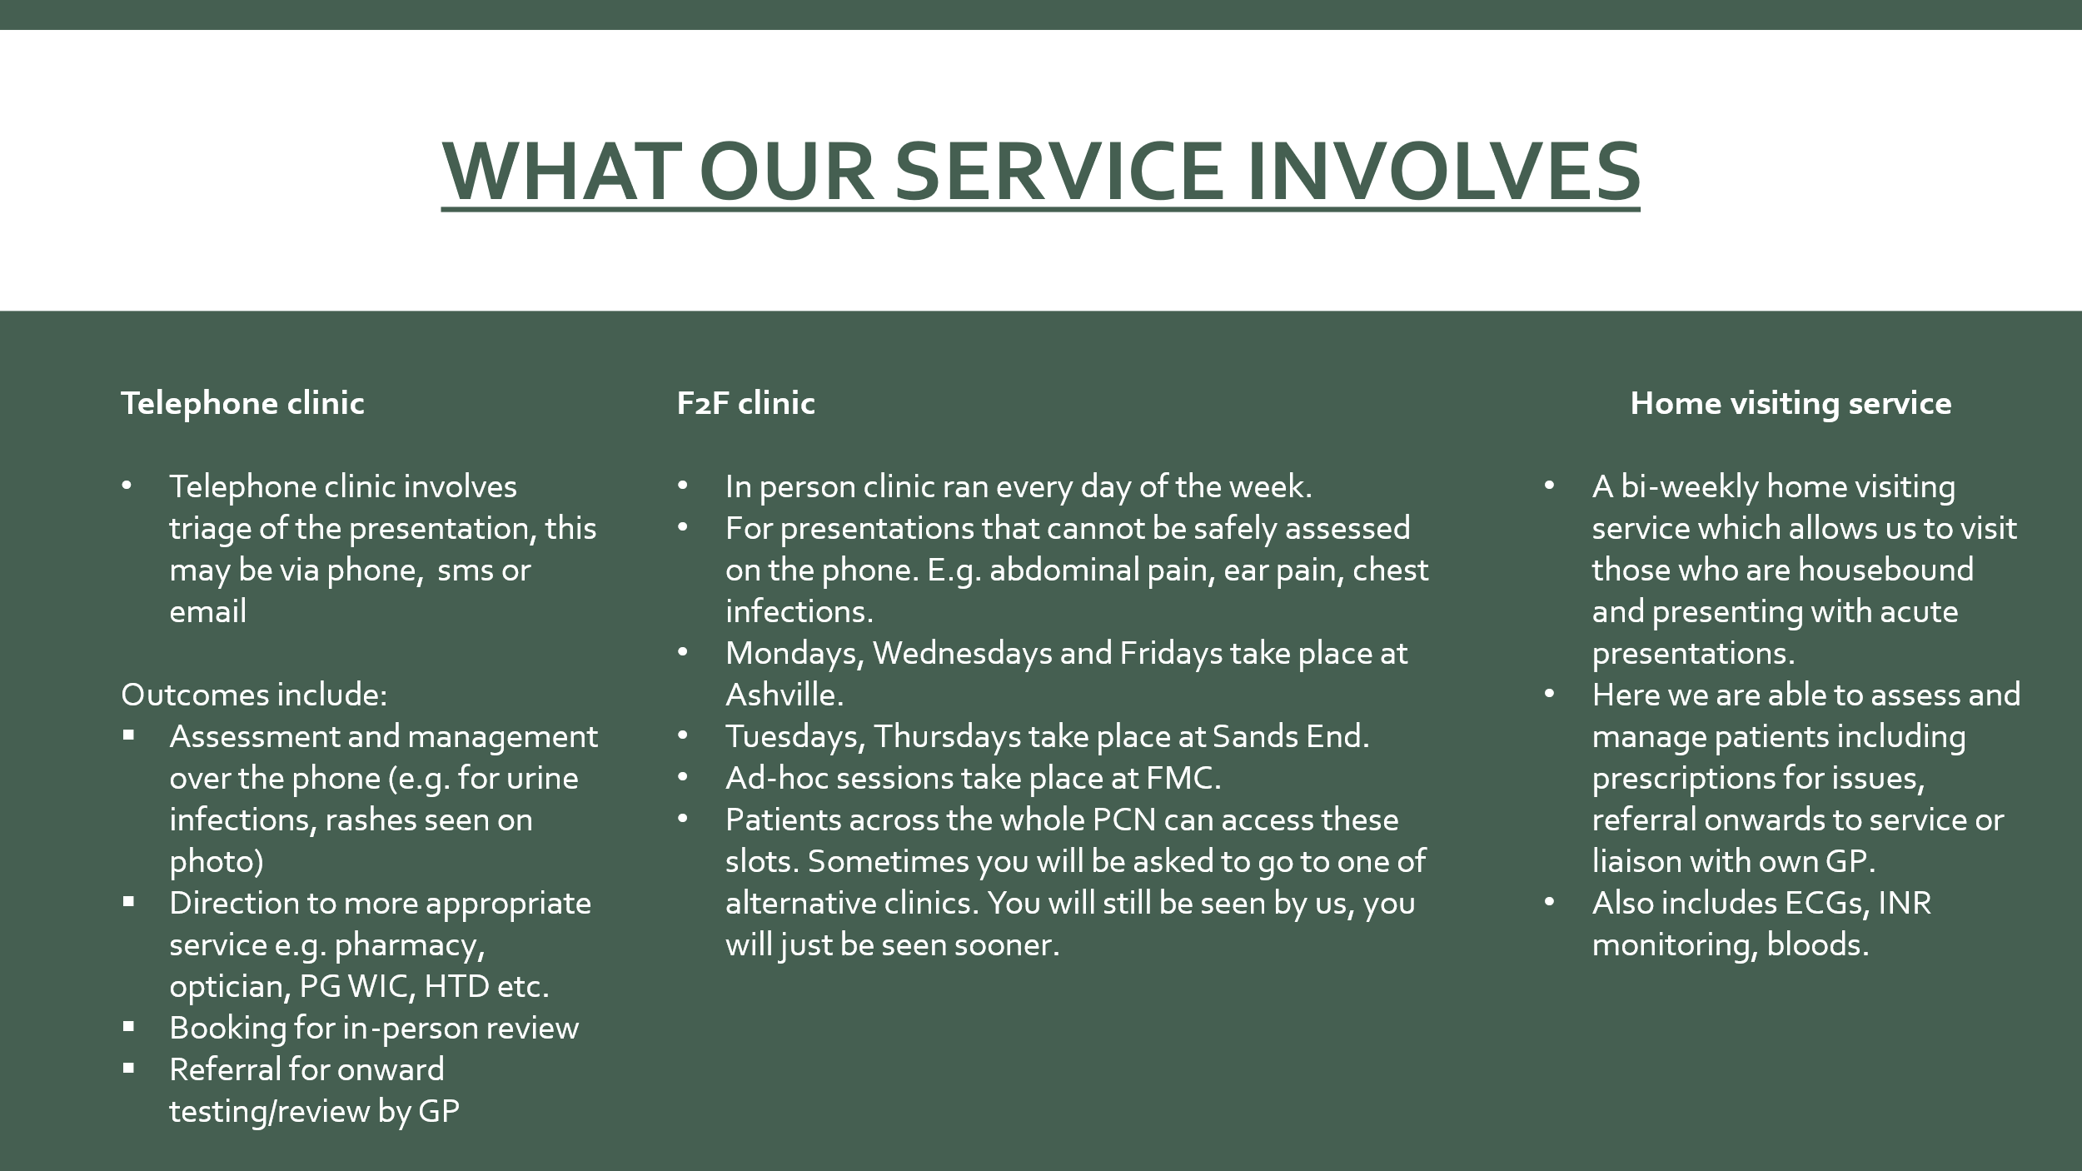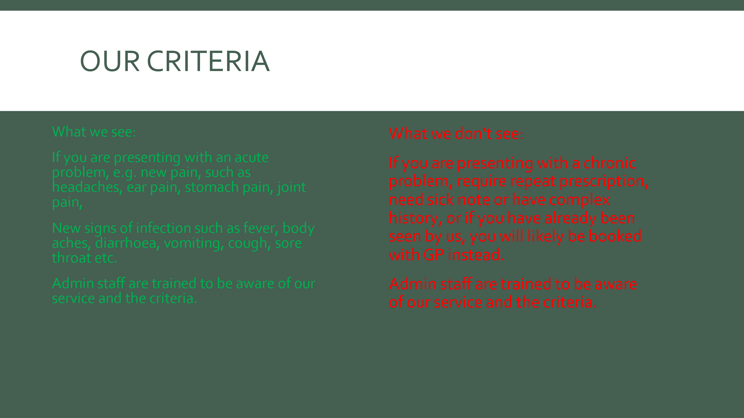
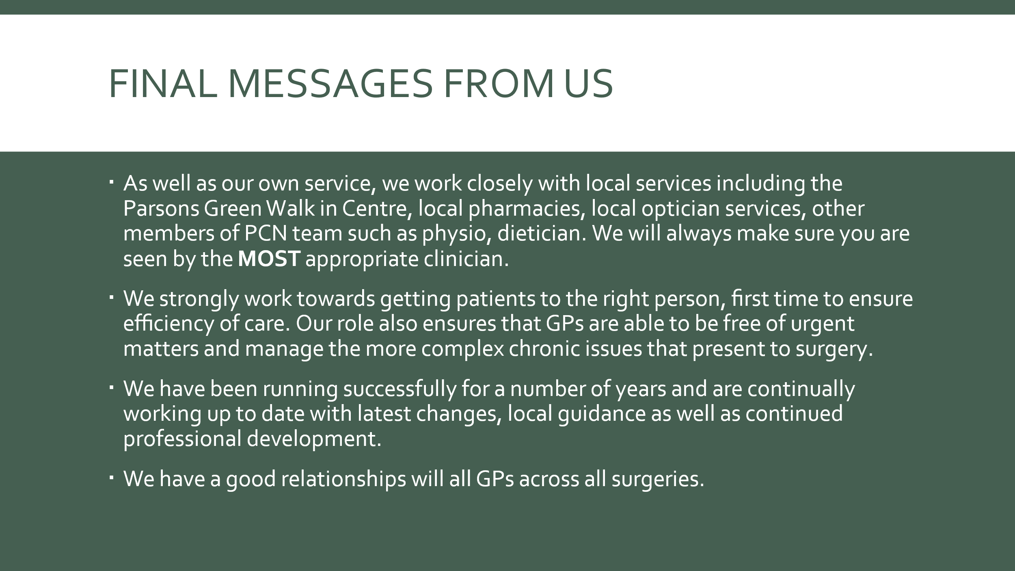
The group were very impressed to hear more about this service. They asked how patients can access this. Kirsty confirmed that patients who were appropriate for this service were automatically allocated to this when their PATCHs (or other methods of surgery contact) were triaged.
Mary asked about PATCHs usage – and whether this was high for Ashville. MN said that we did encourage most patient to use this platform, and did have a good uptake. Of course, where patients cannot use PATCHs, they can still contact the practice by phone / in person – and will be put on the same pathway for care as all other patients.
4 Surgery developments
- New practice manager
MN again introduced the group to Linh, who has taken over as practice manager. He thanked the PPG for all their contributions over the years. The group also wanted to thank MN for his work, and to welcome Linh.

- Autumn and winter vaccination programmes:
  - Flu: eligible patients are being invited from now to book slots from OCTOBER onwards. For more info: Flu vaccine - NHS
  - COVID vaccinations; we do not give COVID vaccinations at the surgery, but patients who are eligible can book slots with local pharmacies via the national booking site. For more info, see: COVID-19 vaccine - NHS
  - RSV – this is now being offered to all patients who are over 75, or live in a care home with older adults. It is also offered to pregnant patients. We do give this vaccination at the surgery. For more info: RSV vaccine - NHS

  - Pneumonia vaccination is offered to babies, people aged 65 and over, and children and adults at higher risk of getting seriously ill. It is usually one dose (though some people may need extra doses or regular doses). We can give this at the surgery. For more info: Pneumococcal vaccine - NHS
5 Any other business
- Repeat prescribing
There was a brief discussion about the 2 months’ supply limit for repeat medications. We had discussed this at the last meeting but Mody correctly pointed out that actually the limit should be described as 8 weeks rather than 2 months. This is due to most pharmaceutical companies creating medication packs in 7-day blister packs / issues, which do not convert neatly into 2 calendar months.
There was also a discussion about the best method to request repeat medications. Most of the group found the online system very convenient. Patients who are unable to use these platforms can still request medication in person, or by phone (though we do try to encourage patients to avoid phone requests if possible to help keep phone line available for more acute medical concerns).
- New registrations
Greta asked about the process for new patients joining the practice. MN said that the process was very quick and easy now; patient can complete online forms, or come to the practice in person. Sandra confirmed that her experience of recently registered a family member had been very quick and easy.
- Named GP
Sandra asked about the NHS contract requirement that all patients have a named GP. MN confirmed that when patients register, they are allocated to a specific GP. Patients can see who their named GP is if they look at their online accounts. We can also let patients know.
Having a named GP does not mean patients would only be seen by that GP. In most cases, we try to allocate patients to clinicians based on what their concern is, and who may have dealt with that concern before. For example, a patient concerned about allergies may be seen by the clinician who they have consulted before about this. We believe this offers patients better continuity of care.
- PSA tests
Rob asked about eligibility for PSA (Prostate Specific Antigen) testing. We can offer this blood test at the surgery. The best way to request this is via PATCHs. A GP would then review the request and discuss this with the patient. For more information on this see: PSA test - NHS
- Google reviews

Linh wanted to remind the group about the value of positive feedback on the surgery, both in terms of staff morale, and in helping with recruiting new patients. We encourage patients to provide feedback (negative and positive) via Google and the NHS.UK site (where patients used to provide reviews) is no longer active.

Patients who want to leave a review can do so via this link: https://g.page/r/CWzjDB1ZM0uzEBM/review

Or scan this QR code:

6 Date of next meeting - to be confirmed

