

Ashville Surgery Patient Participation Group NOTES & ACTIONS
Thursday 18 MARCH 2026, 17.00-18.00 (in person and via MS Teams)

Present: | In attendance:
Anza CLARKE (in person) | Magnus NELSON, Practice Manager, Ashville
Mody KREITMAN (in person) | Lesley HUNTING, Notes Summariser, Ashville
Sandra SMITH GORDON (Teams) | Nevres NIYAZI, Link Worker, South Fulham PCN
Andrew GOODWIN (Team) | Jennie BEACH, GP, Ashville

1 Welcome and introductions
- MN welcomed all to the meeting.
2 PCN developments
- Social Prescribing presentation – Nevres NIYAZI (Link Worker, South Fulham PCN)
Nevres gave an overview of Social Prescribing. The service is managed by the PCN, with Link Workers allocated to practices within the PCN (based on list size). There was a discussion about how patients are made aware of this service. This could be via appointments with the GP (or another clinician) who could then refer the patient to the service. We have also included information about this service in our newsletters, and on the PCN website. The PCN have also created videos of what Link Workers do (along with videos about other services provided by the PCN at practice level). For more information on this, see South Fulham PCN - YouTube
Below is summary of Nevres’ presentation.
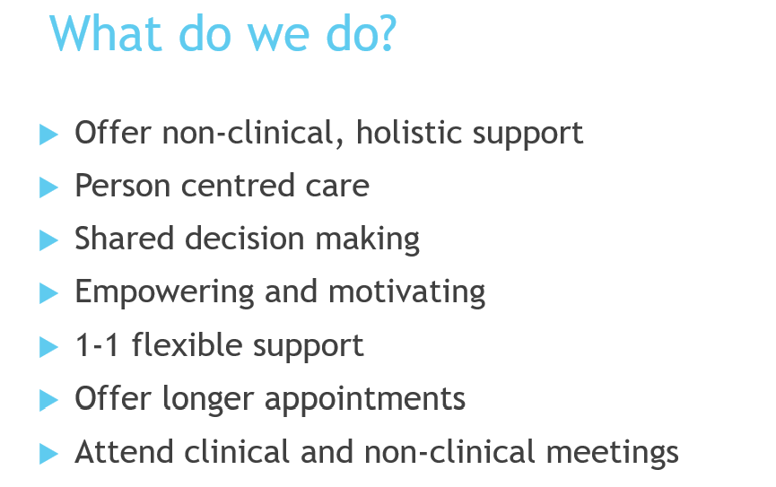
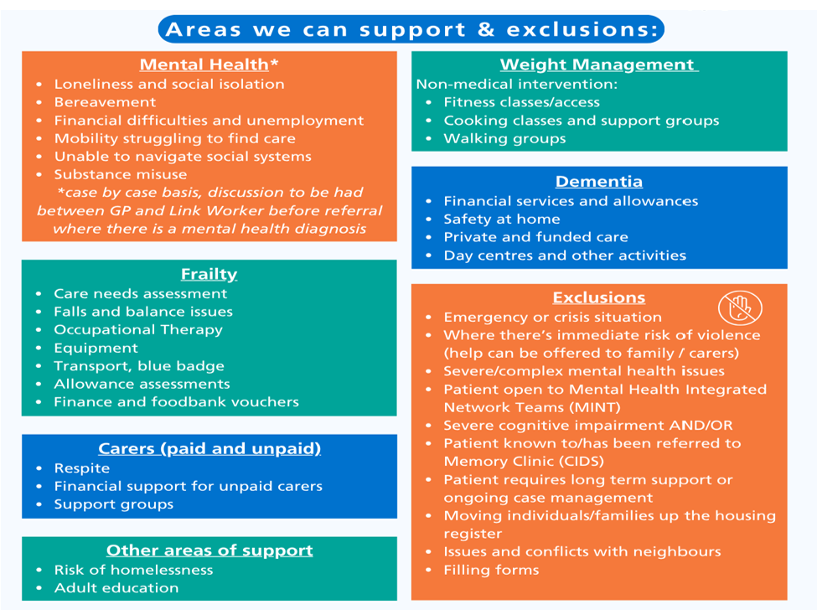
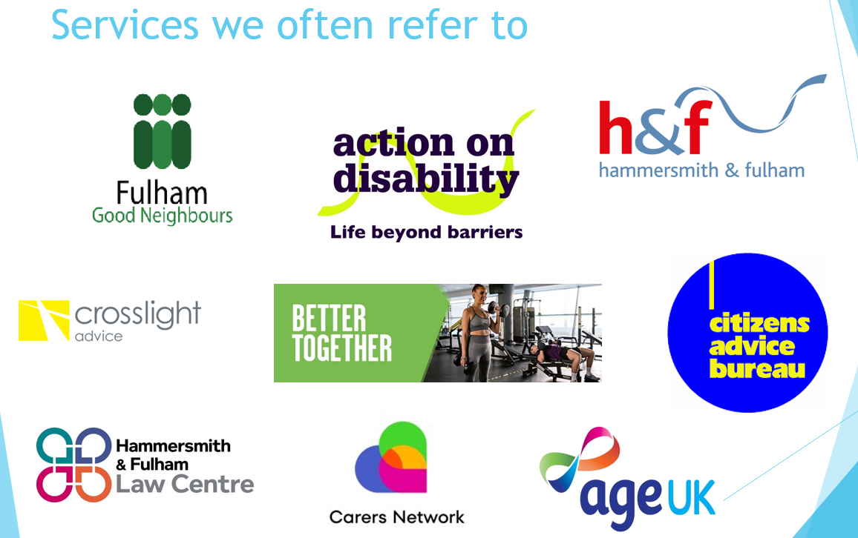

3 Minutes from 13 MARCH 2026 (matters arising)
- PPG membership
We had discussed this at our last meeting, and the recent low attendance. Firstly, MN thanked those who were attending today, and who regularly attended. We will have a push to try and get more members to attend, as well as recruiting new members. All new patients who register with the surgery are asked if they would like to join the PPG.

4 Surgery developments
- New Cardio Renal Metabolic contract
We are running a new NHS screening programme. We are looking for high risk patients that may go on to develop heart disease, diabetes and kidney disease which can make them unwell in later life. If we screen and treat these early, we can prevent and delay these horrible conditions from developing. The check typically involves having a blood pressure check, blood tests, weight, height etc and some lifestyle questions.

A GP, nurse or pharmacist will follow up on this initial appointment by reviewing patient results and patients may be invited in for a face to face, or phone appointment, to look at their individual risks and together explore ways to reduce them. This may involve lifestyle changes or medications which can help, and the clinician will tailor-make a plan with each patient. We will then follow up with the patient after a few months to see how they are getting on.

This is a new service, and we are still finding our way with how best to deliver it.

- Dr Stephen Aras
Message from Dr Stephen Aras – Senior GP Partner from 1993 to 2026

I would like to thank everyone connected with the Ashville Surgery, especially my patients and staff who have contributed so much over the last 33 years from the humble beginnings at 761 Fulham Road to what we have now at Swan House. I have received so many kind words, cards and gifts, too many to reply to individually but I do sincerely thank each and every one of you. It has been an honour and a privilege to serve as a local SW6 GP for over half my lifetime but now it’s time to say goodbye and thank you and to move on to pastures new. Having grown up in Parsons Green, attended Sulivan School and lived in the area for most of my life I will still maintain contact with the area so may well see you around! I leave Swan House and the Ashville GP Partnership in excellent hands and wish you all the very best of health and happiness, Stephen
- Magnus Nelson and new Practice Manager
MN informed the PPG that after 11 years in post, he would also be leaving the practice at the end of AUGUST. His replacement has been appointed, and we will organise a PPG meeting before he leaves so that PPG member can meet the new Practice Manger.

- The Ashville Newsletter:

We are now 21 issues in and counting. MN reminded attendees that if they ever have suggestions for content, to please let him know.

5 Any other business
- Repeat prescribing
Mody asked about the rationale for only prescribing 2 months’ worth of a medication. Others also found this frustrating.
The 2 months limit is based on NHS prescribing guidelines; the NHS typically issues a maximum of a two-month supply of medication to balance patient safety, allow regular monitoring, and reduce medication waste. Though we recognise that this can be frustrating, we do try to make reordering medications as straightforward as we can.
- Correcting medical records
We had a brief discussion about what patients can do if they feel there are inaccuracies on their medical record. We can change or update patient records where the information is incorrect. Where a patient disagrees with a consultation note or diagnosis, we can add a note to record that.
For more information on this, see Amending patient and service user records - NHS England Digital
6 Date of next meeting
Thursday 27 AUGUST 2026, 17.00-18.00 (in person and via MS Teams)
Join: https://teams.microsoft.com/meet/327888423586137?p=nhFUmk7O4cw204MYXu
Meeting ID: 327 888 423 586 137
Passcode: Nk32gw3x

