
Ashville Surgery Patient Participation Group NOTES & ACTIONS
Thursday 12 MARCH 2026, 17.00-18.00 (in person and via MS Teams)
Present: | In attendance:
Anza CLARKE (in person) | Magnus NELSON, Practice Manager, Ashville
Mody KREITMAN (Teams) | Lesley HUNTING, Notes Summariser, Ashville
Sandra SMITH GORDON (Teams)
Apologies: | Apologies (Continued):
Heather PONTIFEX | Juanita TENNYSON DEYNCOURT
Genevieve HACKETT | James WHEELER
Andrew GOODWIN | Scott HILL
1 Welcome and introductions
- MN welcomed all to the meeting and noted apologies as above. We had been expecting more attendees, but on the day had received some additional apologies.
2 Minutes from 6 NOV JULY 2025 (matters arising)
- Surgery works project with the view to creating more clinical space. This project was about converting an admin space into a clinical space and moving that admin space to a new room where – currently – paper notes are stored. The plan was to digitise paper notes to free up the space for office use. UPDATE since our last meeting, the project has now been postponed (indefinitely). A combination of timings and complicated project management requirements from the contractors has made this plan unfeasible at the moment. However, our paper notes have now all been digitised.

- Dr McWhirter: Maternity leave from DEC 2025. We have now recruited 2 long terms locums to replace 6 of her 7 clinical sessions: Dr Anna (THURS / FRIDAY) and DR Yash (MONDAYS).
3 Surgery developments
- End of year targets
March is a busy period for the practice as we are working on hitting the various end-of-year contract targets that we are set by NHS England and the local ICB (NWL). We are also beginning to work on targets that have been set for the coming year (2026-2027).
- MMRV
From JAN 1 2026, Varicella (Chicken pox) has been included in the MMR vaccine, and the schedule has been changed so that babies get this at 1 yr old and at 18 months (before, they go their second dose when they were 3 and a half.
There have recently been a few measles outbreaks in NWL.

- The Ashville Newsletter:

We are now 17 issues in and counting. MN reminded attendees that if they ever have suggestions for content, to please let him know.

- AI developments
We are watching AI developments carefully. We use some aspects already (eg, letters being coded to patient records). There will undoubtedly be some time-saving benefits for practices, but we feel a cautious approach at this stage is wise.

- New GP Contract 2026-27
Mody asked a question about this, and the requirement for same days appointments.

The 2026/27 GP Contract includes a requirement that patients identified by the practice as clinically urgent must be dealt with on the same day. We already have a Duty Dr system in place for this. Patients are added to this list for the GPs to triage. For example, babies with fever / rash would be considered clinically urgent and be dealt with on the same day by the Duty GP. Other concerns might still be triaged on the day, but the GP may decide that the patient can be dealt with later in the week (for example, a patient who is running out of their medications but has enough for the next few days).
4 PCN developments
- New Access contract: Patient Survey
As part of the new Access contract, surgeries were asked to circulate a new patient survey to patients. MN presented some of the initial findings from this. The PCN will be looking at the data and working out what the next steps should be. Below are some of the highlights from this latest survey.

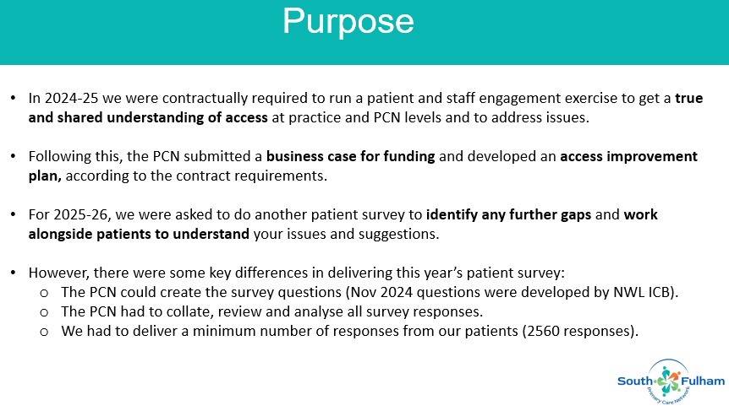
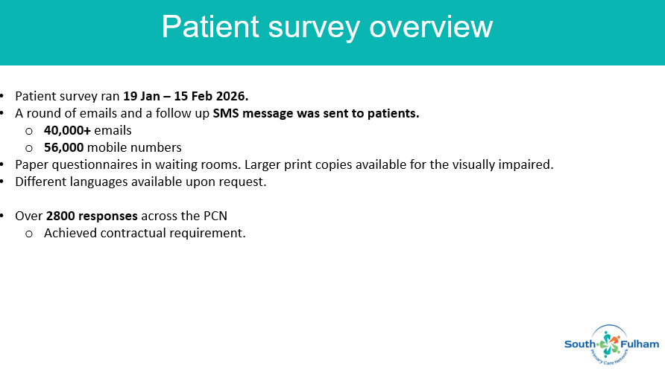
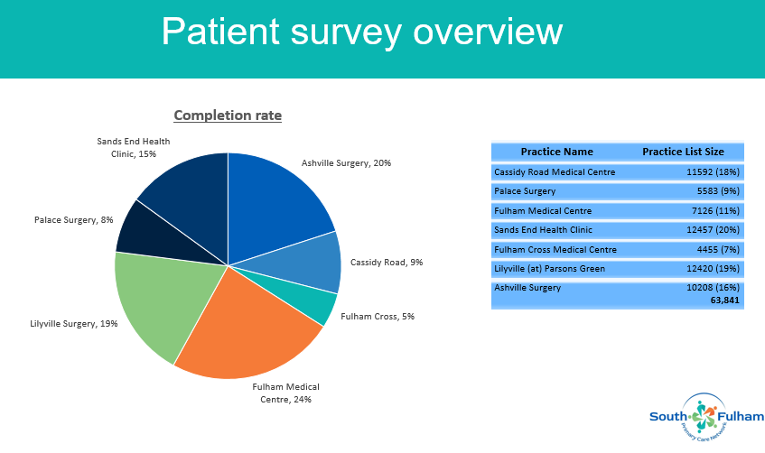

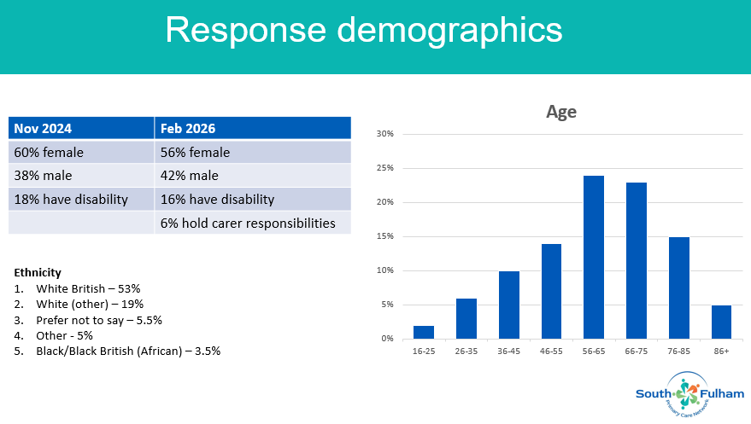
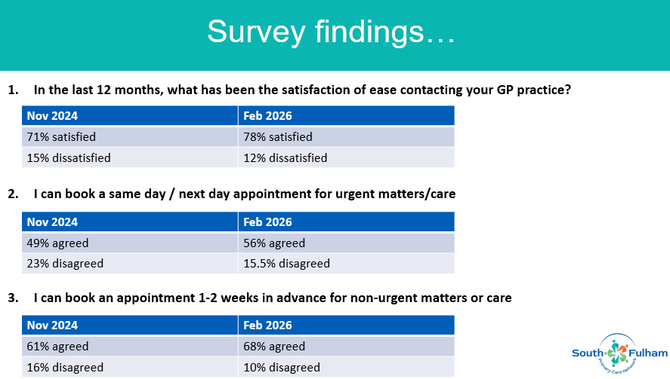
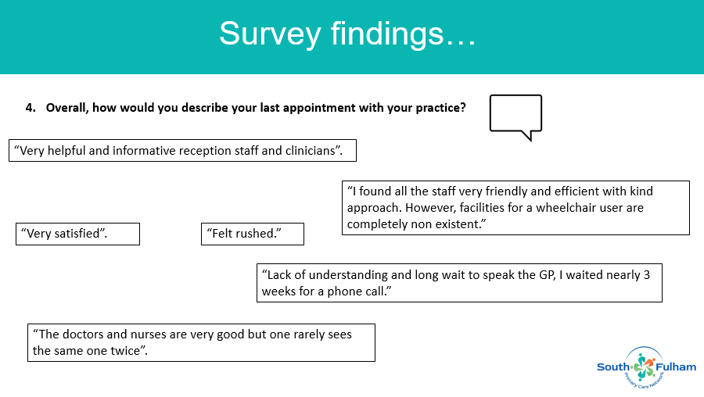
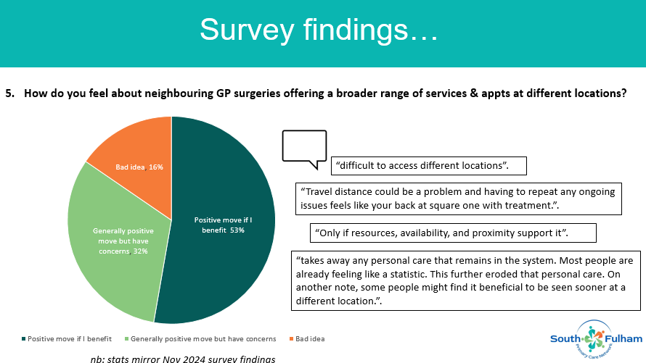
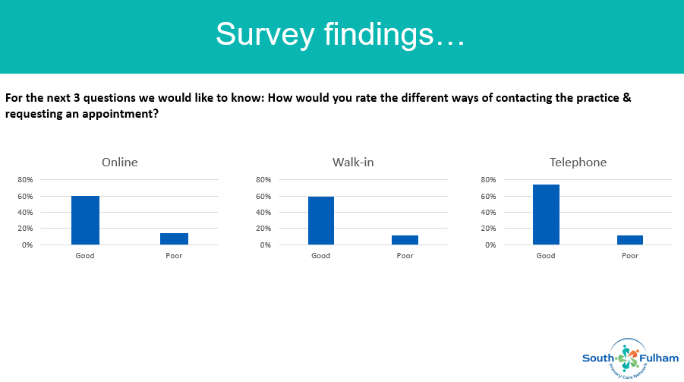
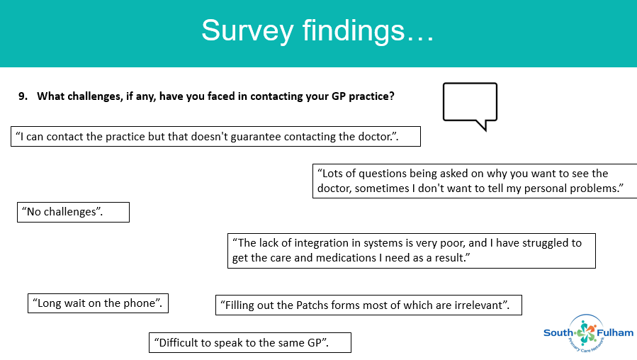
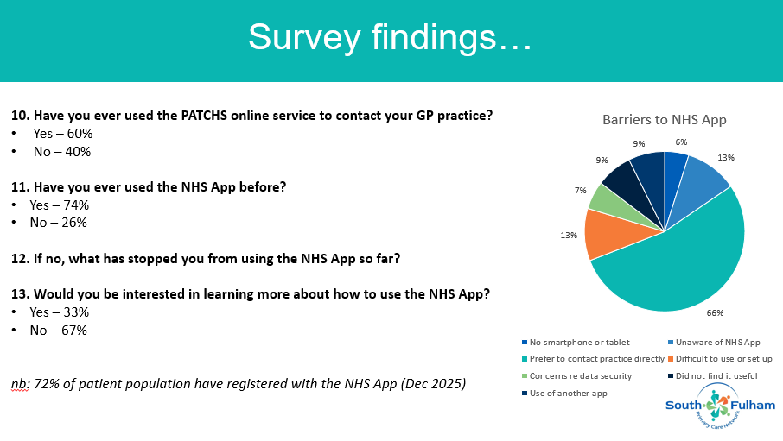
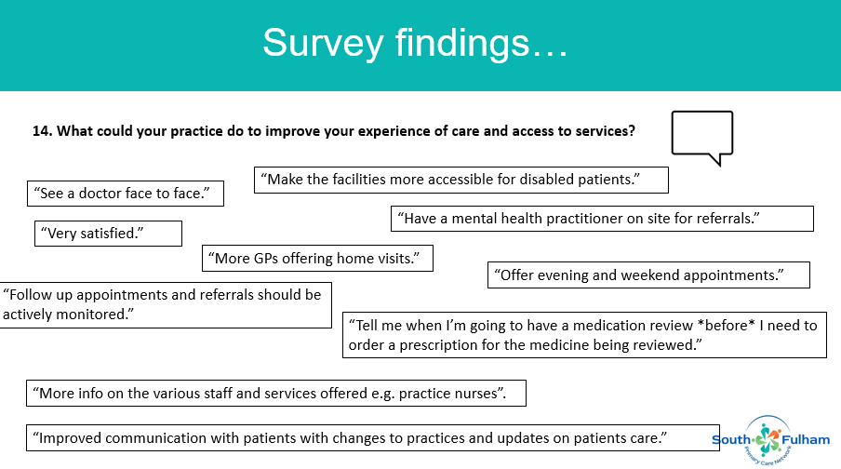
5 Any other business
We had a discussion about how to increase attendance at our PPGs. MN agreed that we needed to try and recruit new members to the group. It was also agreed that when sending out these minutes, he would ask the group for their thoughts and suggestions around increasing engagement and attendance.
6 Date of next meeting
Thursday 18 JUNE 2025, 17.00-18.00 (in person and via MS Teams)
Microsoft Teams meeting
Join: https://teams.microsoft.com/meet/31374875765979?p=mUEF9xmqIVaBH3gBR5
Meeting ID: 313 748 757 659 79 Passcode: b5Rn25PF

