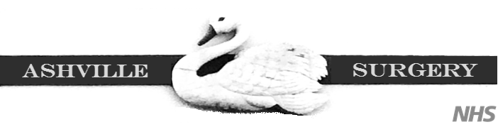

Ashville Surgery Patient Participation Group NOTES & ACTIONS
Thursday 6 NOV 2025, 17.00-18.00 (in person and via MS Teams)
Present: | In attendance:
Anza CLARKE | Magnus NELSON, Practice Manager, Ashville
Mody KREITMAN | Lesley HUNTING, Notes Summariser, Ashville
Su LUTCHMANSINGH (via MS Teams) | Beverly BOGLE, Admin, Ashville
 | Dr Mo RASHIDY, GP, Ashville
Apologies:
Heather PONTIFEX | Apologies (Continued):
Sandra SMITH GORDON | James WHEELER
Andrew GOODWIN | Najat BENELABED
Adine DIGGLE | Zahra OMAR
Laura PATERSON

- Welcome and introductions
- MN welcomed all to the meeting, and noted apologies as above.
2 Minutes from 17 JULY 2025 (matters arising)
- Surgery works: to create more clinical space. This project is currently on hold. We are awaiting an update from the surveyors as to when and whether this project can proceed. (This is about converting an admin space into a clinical space, and moving that admin space to a new room where – currently – paper notes are stored. The plan is to digitise paper notes to free up the space for office use).

- Winter vaccinations: Flu, COVID, RSV . MN reminded all about these 3 vaccinations. For more information on who is eligible for these, please see: Winter vaccinations and winter health - NHS
3 Surgery developments
- The Ashville Newsletter - issue 14:

We are now 14 issues in and counting. MN reminded attendees that if they ever have suggestions for content, to please let him know. Su suggested that a feature on how PATCHS works would be useful: eg, what happens to a PATCHs once submitted, how is it triaged and allocated. MN agreed to add an item covering this into the DECEMBER issue.

The group discussed how PATCHs are currently processed. MN described the process (in simple terms) as below:

Patient completes a PATCHs

eHUB team (of care navigators) receive and process the PATCHs (add it to the patient’s record, and flag up to the practice team).

eHUB team sends patient a message to confirm receipt of their PATCHs.

Practice team allocates the PATCHS to a clinician (GP, nurse, paramedic – depending on the request and urgency. Eg, a baby with a rash – would go to the same day duty dr, a patient requesting a routine blood test would go on the next available clinician slot – which could be same day, or could be a few days later).

The above process is simplified here, and there are variations in how a PATCHs might be handled. Some will go direct to an admin team to deal with (eg, a request for the patient’s vaccinations). In other cases, the clinicians may require further information from the patient (eg, a photo). MN will aim to provide a more thorough process in the next newsletter. To re-assure patients, the time it takes for us to process and deal with PATCHs is closely monitored and audited, and all PATCHs are seen and dealt with by a human, not AI.

Another suggestion for the newsletter was around comparative data – to show how surgeries and areas are performing compared to each other. MN will see what data is available and include this in the next editions.
Other suggestions for content included providing advice and guidance on what to expect after a diagnoses (eg information and sources of support and signposting.
- New Access contract: Patient Survey
As part of the new Access contract, surgeries will be asked to circulate a new patient survey to patients. More information will follow about this, but MN just wanted to advice the group in advance that this new survey is coming.
- Dr McWhirter: Maternity leave from DEC.
Dr McWhirter will be going on maternity leave from DEC 2025. Her sessions will be covered by 2 locums (Dr Anna and Dr Yash).
- New boiler
The surgery has a new boiler! The previous one had to be replaced at short notice.
- Structure of our PPG

MN asked the group to consider how they think it should be structured. Some PPGs have their own appointed patient chairs who set agendas and dates. If our group prefers, MN is happy to continue as chair. From time to time, the group does need to re-visit this item, to make sure that the group is fit for purpose, and functioning as members would like it to.

For the moment, attendees agreed that that they would prefer the group to continue in its current form and structure.

- The NHS Patient Charter: You and Your General Practice

You and Your General Practice (YYGP) has been developed to help patients understand what to expect from general practice and how they can get the best from their GP team. It also enables patients to provide feedback or raise concerns with their GP Practice, Healthwatch or Integrated Care Board. For more info, please see: https://www.nwlondonicb.nhs.uk/contact-us/patient-feedback-and-complaints/nhs-patient-charter-you-and-your-general-practice

4 PCN developments
- PATIENT INFORMATION & ENGAGEMENT GROUP (PIEG)
Monday 17th Nov, Time: 5.30-6.45pm, Location: Lilyville Surgery

The PCN is holding a PIEG meeting on 17 NOV. PPG members are very welcome to attend. For more info, please see below. If patients do want to attend, please email : southfulham.pcn@nhs.net to book a place.

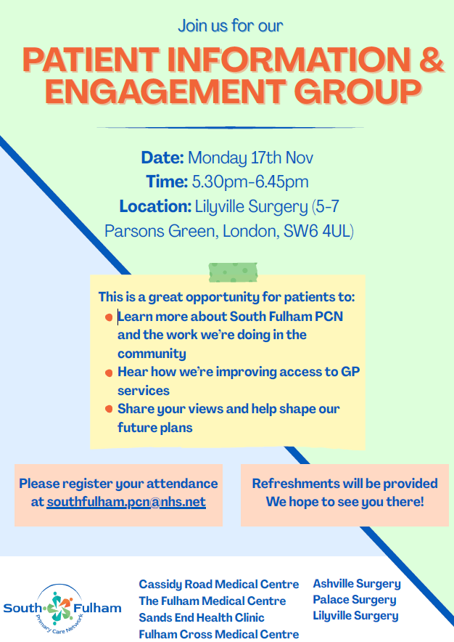

- New paramedic:

Denise has joined the PCN team as a paramedic
5 Any other business
6 Date of next meeting
Thursday 12 MARCH 2025, 17.00-18.00 (in person and via MS Teams)
Microsoft Teams Need help?
Join the meeting now
Meeting ID: 329 610 296 794 24
Passcode: pc9D3zD6

