**South Fulham PCN Patient Participation Group meeting  
TUESDAY 14 MARCH 2023, 6.00pm (in person and via MS Teams)**

|  |  |
| --- | --- |
| Nina SHANDLOFF (via MS Teams) | Ashville |
| Mordechai KREITMAN (via MS Teams) | Ashville |
| Heather PONTIFEX | Ashville |
| Juanita TENNYSON DEYNCOURT | Ashville |
| James WHEELER | Ashville |
| Andrew GOODWIN (via MS Teams) | Ashville |
| Magnus NELSON | Practice Manager, Ashville |
| Leslie HUNTING | Admin, Ashville |
| Lila Mann (via MS Teams) | Cassidy Road |
| Abu OSMAN (via MS Teams) | GP, Cassidy Road |
| Sarina GURUNG | Practice Manager, Cassidy Road |
| Sharon KHUMALO (via MS Teams) | Community Matron, CLCH |
| Nadia AWAN (via MS Teams) | Practice Manager, Fulham Cross |
| Joseph FAMEWURA (via MS Teams) | Fulham Cross |
| Talina ELLIS (via MS Teams) | Fulham Cross |
| Hassan ASLAM (via MS Teams) | Fulham Cross |
| Nancy LEES | Fulham Medical |
| Rosemary RADCLIFFE (via MS Teams) | Lilyville |
| Varsha CHOHAN | Practice Manager, Lilyville |
| Emily WESTON PRICE (via MS Teams) | GP Lilyville and Clinical Lead, PCN |
| Laura LEONARD, (via MS Teams) | Palace |
| Julian PATTEN, (via MS Teams) | Palace |
| Nuwan PATHIRINAGE (via MS Teams) | Practice Manager, Palace |
| Patricia WARD (via MS Teams) | Admin, Palace |
| Celina CHILEK (via MS Teams) | Sands End |
| Richard EDWARDS (via MS Teams) | Sands End |
| Caroline JEWELS (via MS Teams) | GP, Sands End |
| Lais LOPES DE ALMEIDA (via MS Teams) | Admin, Sands End |
| Ross LAMBDON | PCN Development Manager |
| Helen POOLE | PCN Managing Director |
| Sophie MIZEN (via MS Teams) | PCN Transformation & Operations Manager |
| Fran TUGWELL (via MS Teams) | Link Worker, PCN |
| Tasmyn ALI (via MS Teams) | Health & Wellbeing Coach, PCN |

1 Welcome and introductions

Magnus welcomed all to the meeting, and invited attendees to introduce themselves.

2 PCN Overview: structure and membership (refresh)

Helen gave a presentation on the PCN (the contents of which are also included in these notes).

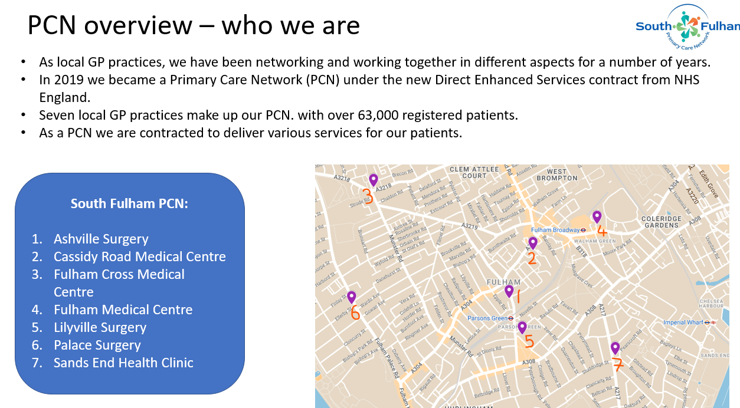

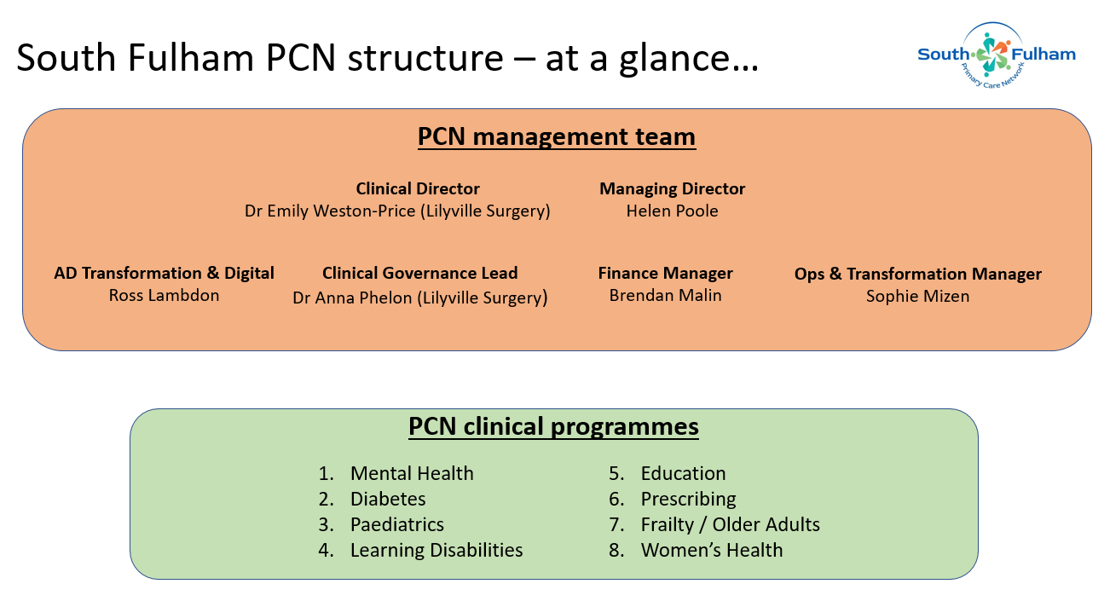

3 New PCN developments

**PCN incorporation: South Fulham PCN Co**

In December 2021, we set up a company - South Fulham PCN Co. It became operational in July 2022. This was to provide a legal entity so we can:

* + Recruit and employ staff directly
  + Directly hold PCN-level contracts with NHS England and NHS North West London
  + Potentially provide direct care as a PCN in the future through registering with the Care Quality Commission
* Each practice has a named Director as a shareholder of the company
* Our PCN Co. has a Board with each practice represented and an Executive team which manages the day to day operations
* As MD, Helen represents the PCN in the borough-wide Health and Care Partnership (HCP)

**ARRS roles (Additional Roles Reimbursement Scheme)**

We have a workforce across the PCN that supports practices and their patients. These roles include; Pharmacists, Paramedics, Link Workers, Health and Wellbeing Coaches, Care Coordinators. They are 100% funded by NHS England up until March 2024, and over the next 12 months we are looking to expand our PCN workforce to provide more services and appointments to our patients.

We will increase our current workforce skill mix through recruiting Physician Associates and an Advanced Nurse Practitioner.

**Clinical programmes**

The PCN has a number of shared clinical programmes and clinics across the PCN to support various cohorts of patients who may have complex needs.

Each programme has a Clinical Lead focusing on service development and ensuring clinical effectiveness and safety.

The programmes look to embed clinical input from various organisations and clinicians across community, hospital and primary care settings to provide targeted and holistic support to patients.

**Home visiting service**

The PCN has a home visiting service into which practices can refer.

The service is delivered by Advanced Nurse Practitioners (ANPs), with daily appointments Mon-Fri for housebound or frail patients who require an assessment.

The ANP will then liaise with the practices to discuss next steps e.g. if a prescription, further tests or examinations are required.

**Enhanced access**

The PCN continues to provide patients with additional access to appointments via various clinicians. Previously known as ‘Extended Hours’, this has been renamed ‘Enhanced Access’ under the new contract with NHS England. Additional appointments are either face-to-face or telephone consultations (with nurses and GPs). These appointments are provided primarily between 6.30 pm and 8pm, though some surgeries offer them pre 8am too.

**Community Development – Thriving South Fulham**

Ross updated the group on PCN work in the community.

We want the PCN to be at the heart of local conversation and action to support local residents’ health & wellbeing. We are actively engaging with local organisations, services and communities so we can understand what really matters to them and how the PCN can be involved.

Our aim: to establish a thriving neighbourhood in South Fulham where we build relationships, share resources and learning, and identify opportunities to work together to proactively support our residents.

2023 brings ’Thriving South Fulham’ – network breakfast meetings, local conversation, health and wellbeing projects, Parsons Green Fair 2023.

**JOY platform**

A new platform has been made available to the PCN and our Link Workers. Launched 13th March 2023. We are the first PCN in H&F to go live.

Benefits include:

* + A quick & easy referral process
  + Ability to track patient outcomes
  + A live directory of local services and organisations

4 PPG priorities

Rosemary kindly offered support, and asked about current challenges facing primary care. Helen replied that staff recruitment is a big challenge. Meeting NHS targets is also a big challenge. But on the positive side of things, the PCN offered lots of opportunities for practices to work closely together, sharing – and adopting – examples of good practice, which of course is ultimately of benefit to patients.

Lila asked about cancer referrals, and prevention services. Emily confirmed that these are priorities for practices, and there are already several schemes in place (around streamlining and standardising referrals). The PCN was striving to ensure that all patients have the same level of access (and uptake) to screening services, and there is currently a lot of work going on around earlier diagnosis.

Lila also asked about practice numbers and how PCN resources are allocated. Magnus confirmed practices have roughly the following number of patients each:

Ashville: 12000

Cassidy: 12000

Sands End: 12000

Lilyville: 10500

Fulham Cross: 4600

Fulham Medical: 6500

Palace: 5500

Emily said that resources were allocated as fairly as possible, based on need and not necessarily practice numbers.

Mody asked about how Link Workers and GP interact. Magnus answered that PCN and practice staff already work closely together – both formally and informally, which allows for a more seamless journey for patients.

1. Any other business

Helen thanked all for coming. It was very important to get input and feedback from patients and this often led to new initiatives and services being set up.

1. Date of next meeting – to be confirmed