

**Ashville Surgery Patient Participation Group  
Thursday 17 October 2024 17.00pm (in person and via MS Teams)**

|  |  |
| --- | --- |
| **Present:** | **In attendance:** |
| Mody KREITMAN (via MS Teams) | Magnus NELSON Ashville Practice Manager |
| Sandra SMITH GORDON (via MS Teams) | Leslie HUNTING Ashville Notes Summariser |
| Heather PONTIFEX | Ross LAMBDON AD for Transformation & Digital SF PCN |
| Juanita TENNYSON DEYNCOURT | Dr Jennie BEACH Ashville GP |
| Apologies |  |
| Zahra OMAR |  |
| Rosy DEV |  |
| Anza CLARKE |  |
| Andrew GOODWIN |  |
| Sue LUTCHMANSINGH |  |
| Buzz WEST |  |
| James WHEELER |  |
| Rob COOPER |  |

1. Welcome and introductions

MN welcomed all to the meeting and noted apologies. As Ross from the PCN was joining the meeting, MN re-ordered the agenda.

2 NWL ICB Access survey

Ross gave a presentation updating the group on South Fulham Primary Care Network (SF PCN).   
MN agreed to share this presentation with the group when he sends out the minutes.   
The main item was the North West London Integrated Care Board’s (NWL ICB) patient survey and focus groups; they are asking all patients across North West London to complete an online survey concerning their access to primary care.

The turnaround for this is very tight, with patients receiving invites this week, and the survey closing in less than a fortnight. The ambition is to achieve a response rate of around 5%.

The aim is to gain a clearer understanding of access in each area e.g. what are the successes we can learn from? And which issues should be addressed?

The ICB also hope to engage with staff and wider stakeholders (i.e. Healthwatch, community organisations etc.) and to organise focus groups with patients and stakeholders to discuss the findings of the survey and to understand patient experience (what matters to you most). This may be via a virtual meeting and two in-person meetings (details to be confirmed). The aim is for these to be completed by mid-November.

ACTION: MN to email PPG member the link to the survey (for ease).

Ross also updated the group on recent PCN developments (see Item 5 below).

3 Minutes from the last meeting (6 June 2024)

MN to develop a newsletter we can share with patients, updating them on new services, staff, etc.   
MN will endeavour to have something ready in time for the next PPG.

4 Surgery developments

* New website: Our previous website host informed us earlier this year that they needed to make changes to our website to fit in with my NHS access guidelines.   
  The content remains largely unchanged, but the layout is different.
* ICB and new online platform procurement.   
  We’ve been informed a procurement process is imminent for an online e-consultation platform.   
  It’s not yet clear whether our existing platform, PATCHs, is of the options under consideration.   
  We have strongly recommended the ICB, when they make their choice, factor in how patients may feel having to learn how to use an entirely new online platform.
* Flu, COVID & RSV vaccinations.   
  We are now offering *eligible* patients flu jabs and the new RSV jab. For more info [https://ashvillesurgery.co.uk/news/rsv-vaccination](https://ashvillesurgery.co.uk/news/rsv-vaccination/) Covid jabs are available to *eligible* patients via local pharmacies.

5 PCN developments

Ross updated the group of PCN developments, providing a snapshot of the current staff mix.

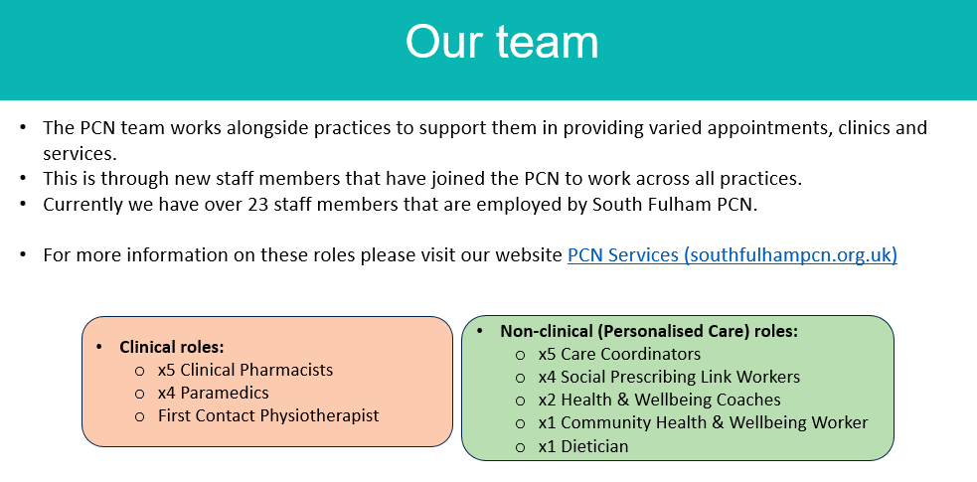

Recent developments include recruiting a First Contact Physiotherapist and a Dietician.   
The PCN has also recruited a 4th paramedic, which means the team will now have the capacity to undertake home visits to patients who require this service. A new Mental Health Support worker is also now on board.

During a discussion about how patients find out about new services (like the ones above) and how they can access them, MN noted we need to ensure patients are made aware of these new services by better signposting e.g. website updates, creation of a newsletter and displaying info in the surgery waiting areas.   
  
Following on from this, there was a discussion about ensuring patients feel confident enough to contact the surgery when they need help. Certainly, we don’t want patients to feel they can’t ask or they are *being a burden*. MN said he would consider this in more depth to see how we can encourage patients who might feel that they *shouldn’t* be contacting the practice.

6 Any other business

MN updated the group on the new Pharmacy First service. This had been mentioned briefly in the previous meeting. The service is more established; patients can now access this service directly, or via the practice. For more info: [www.england.nhs.uk/primary-care/pharmacy/pharmacy-services/pharmacy-first](http://www.england.nhs.uk/primary-care/pharmacy/pharmacy-services/pharmacy-first)

7 Date of next meeting – to be confirmed