

**Ashville Surgery Patient Participation Group  
Thursday 17 July 2025, 17.00pm (in person and via MS Teams)**

|  |  |
| --- | --- |
| **Present:** | **In attendance:** |
| Anza CLARKE | Magnus NELSON, Practice Manager, Ashville |
| Robert COOPER (via MS Teams) | Lesley HUNTING, Notes Summariser, Ashville |
| Rosie DEV | Beverly BOGLE, Admin, Ashville |
| Mody KREITMAN |  |
| Sandra SMITH GORDON (via MS Teams) |  |
|  |  |
| Apologies: |  |
| Andrew GOODWIN |  |
| Heather PONTIFEX |  |
| Zahra OMAR |  |

1. Welcome and introductions

MN welcomed all to the meeting and noted apologies.

2 Minutes from 13 March 2025 (matters arising)

* Assisted dying; this had been discussed briefly at the last meeting. Since then, the Assisted Dying Bill has been approved in parliament, subject to amendments etc. There is no date when it will come into law, or what the specific measures will be in regard to the impact this has on primary care.

3 Surgery developments

* Ashville Newsletter

Now on its 10th Edition. MN asked the group to continue suggesting feedback and ideas for content. Overall, the group felt the newsletter was a useful resource.

Sandra mentioned that one of the standing items (patient feedback), incorrectly uses the word ‘verbose’ when referring to written feedback from patients. Sadly, this is a feature embedded into the software that collects the data and MN is unable to change this, though he may be able to ‘hide’ this in the 11th edition.

* New staff:

Kassandra and Lia have joined the practice as part time receptionists. Alline is now on maternity leave.

Jesrey has now left the surgery to pursue his law career.

* Weight loss drug: Mounjaro

There has been a lot in the news recently about weight loss medications, which has meant that many patients have been contacting us about this. Eligibility for this medication is limited. NWL ICB have produced guidelines that set out who is eligible. For more info, click [here](https://www.nwlondonicb.nhs.uk/news/news/tirzepatide-and-nhs-north-west-london).

* New childhood vax schedule

From 1st July 2025, the NHS is changing the childhood immunisation schedule.

These changes will apply to children born on or after 1st July 2024. For children born before that date, they will follow the previous NHS schedule. For more information, see the links below.

[Routine childhood immunisations for babies born before 1st July 2024](https://www.gov.uk/government/publications/routine-childhood-immunisation-schedule/routine-childhood-immunisations-from-february-2022-born-on-or-after-1-january-2020)

[Routine childhood immunisations for babies born on or after 1st July 2024](https://www.gov.uk/government/publications/routine-childhood-immunisation-schedule/routine-childhood-immunisations-from-1-july-2025-babies-born-from-1-july-2024)

* Reminder about RSV vaccine

The RSV vaccine helps protect against respiratory syncytial virus (RSV), a common virus that can make babies and older adults seriously ill. It's recommended during pregnancy and for adults aged 75 to 79. For more info, click [here](https://www.nhs.uk/vaccinations/rsv-vaccine/).

The group also asked about COVID vaccinations. There has been a Spring 2025 campaign, and there is likely to be a new campaign for the Autumn too.

Details of the Spring campaign are below:

COVID vaccinations: there will be a Spring Booster campaign for 2025. The COVID-19 vaccine is recommended for people at increased risk from COVID-19. Patients may be offered a COVID-19 vaccine in spring if they:

* + are aged 75 or over
  + are aged 6 months to 74 years and have a weakened immune system because of a health condition or treatment
  + live in a care home for older adults

For more info: <https://www.nhs.uk/vaccinations/covid-19-vaccine/>

* Surgery works – planning stage

Ashville has been selected as a potential site to create more clinical space. The proposal is that the current Practice Manager’s office is adapted into a clinical room for patient consultations. The current PM’s office would then move upstairs into the space currently occupied by paper notes. The plan is to send paper notes for digitisation (thereby freeing up space for an office).

These plans are at an early stage still.

* GP National Survey

The latest GP Patient survey results are out. Below is a snapshot of Ashville’s data (which you can also view [here](https://www.gp-patient.co.uk/patientexperience/results?code=E85719)).

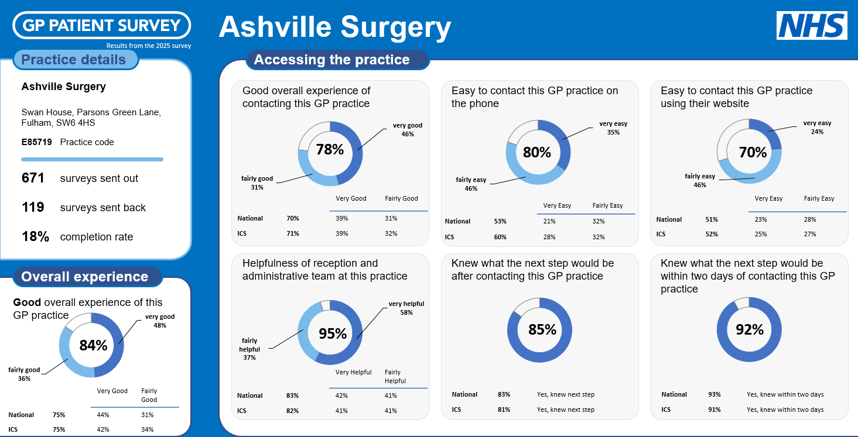

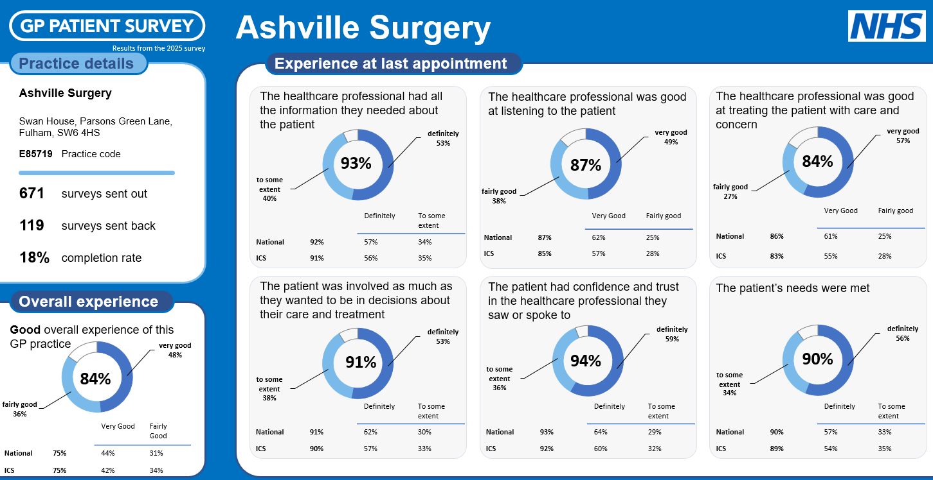

Click [here](https://www.gp-patient.co.uk/) for more info.

This led to a discussion on other sources of patient feedback. MN summarised the main sources as:

Friends & Family data: this is a survey that patients are invited to complete after an appointment. Patients are sent a test message asking *overall, how was your experience of our service?* (with an option to add further info: Please tell us why you gave this answer). MN uploads a monthly report onto our website and provides a snapshot of data in the newsletter.

For recent results, please see <https://ashvillesurgery.co.uk/friends-and-family-test-results/>

Google reviews: any patient can write a review about their experiences at Ashville on google <https://g.co/kgs/EhKgy1N>

See screenshot below. In reality, patients are often motivated to feedback when things have gone wrong or they are not happy with our service. We do encourage patients to use that platform for feedback and MN does reply to all reviews (good and bad).

. 

4 PCN developments

* Additional Roles Reimbursement Scheme (ARRS) New GP – Dr Anna

A new GP (Dr Anna) is due to start at Ashville in AUGUST. She has been recruited by the PCN and will work with us on WEDNESDAYS from AUGUST to MARCH. This will really help us with the workload. Dr Anna has been working with neighbouring surgeries Lilyville and Fulham Medical, so she is familiar with referral pathways for our area.

Rob asked if we’d noticed any trends in terms of what patients are contacting us for.

MN mentioned requests for Adult and child ADHD assessments, weight loss and summer ailments like hay fever. He said he would also ask the GPs, who subsequently came up with these responses:

- Total body mole checks in young people (usually with normal moles).

- Patients with anxiety and work-related “stress/bullying”

- Younger patients (20-30 yr olds) expecting very quick responses (even for minor issues)

5 Any other business

First Contact Physiotherapist (FCP)

There was a discussion about the PCN FCP. MN will feedback to the PCN re: some recent interactions with the FCP. For more details on this role, please see [First Contact Physiotherapist - YouTube](https://www.youtube.com/watch?v=VBZOFHUKU7o)

Annual health checks

There was a discussion about patients being offered annual health checks / check-ins (eg to discuss medications etc) with a GP. There is a national health check programme for patients aged between 40-75, though this is usually carried out by our HCA rather than a GP. This involves blood tests (for lipids and sugars) and physiological measurements (height, weight, BP etc). The aim of this programme is to identify patients who may be at risk of developing conditions in the future, eg, diabetes. For more information see <https://www.nhs.uk/tests-and-treatments/nhs-health-check/>

Similarly, patients on some specific medications are invited for annual (or more frequent) monitoring and patients who are on several medications are offered medication reviews.

However, at the moment there is no defined programme to invite all patients in for a general review. But if a patient is on several medications, we would encourage them to contact us to arrange a consultation with the practice pharmacy (who can also escalate any concerns to a GP if needed).

Blood tests and recalls

The group discussed how patients are called back in when they have previously had an abnormal result (eg high cholesterol). There was a concern that a patient might fall between the cracks if they had had a high result in the past, then a normal one, but were at risk still of further high / abnormal results.

Sadly, there isn’t capacity to screen everyone but patients who are on specific medications are invited in for regular monitoring, and patients with certain conditions (eg, diabetes, asthma, COPD) are be invited in for regular reviews.

Patients who have previously had high results can always contact the practice to have these repeated if they are worried.

Use of AI in the practice

There was a short discussion about the use of Artificial Intelligence (AI) in the practice. Currently, a lot of the correspondence (clinical letters) the practice receives from hospitals is processed using some AI software. This identifies key words in the letter (eg, hospital specialties like cardiology or dermatology) and adds these codes to patient records. At the moment, all these letters are still reviewed by a clinician, but the AI function does speed up the admin processes in adding letters to the patient’s record.

Similarly, our PATCHs software has an AI component, though this can be a bit clunky. If the system identifies certain conditions (based on key words) patients are then asked to provide more information, or to complete a questionnaire about their condition (often one that is not relevant to the patient’s original concern!). PATCHS are aware of this, and are refining their AI algorithms all the time.

The direction of travel is almost certainly towards more AI being used in primary care and in healthcare more generally.

6 Date of next meeting – Thurs 6 NOV 5-6pm (online and in person)

MN thanked all for coming. He will confirm the date of the next meeting shortly. He reminded all that if they have suggestions or feedback to contact him. Similarly, if they have any concerns, they can get in touch with him and don’t need to wait for the next meeting.