

Dr S Aras Dr J Jenkins Dr J Beach Dr M Rashidy Dr A Ryan Dr K McWhirter  
 Practice Nurses: Jenny Chetwynd, Sally Gillibrand   
Practice Manager: Magnus Nelson

**Ashville Surgery Patient Participation Group  
Thurs 15 February 2024, 17.30pm (in person & via MS Teams)**

|  |  |
| --- | --- |
| **Present:** | **In attendance:** |
| Mody KREITMAN | Magnus NELSON, Practice Manager, Ashville |
| Sandra SMITH GORDON (via MS Teams) | Lesley HUNTING, Notes Summariser, Ashville |
| Rosy DEV | Beverley BOGLE, Admin |
| Apologies: | Sophie MIZEN, Ops Manger, SF PCN |
| Nina SHANDLOFF |  |
| Anza CLARKE |  |
| Heather PONTIFEX |  |
| Andrew GOODWIN |  |

1 Welcome and introductions

MN welcomed all to the meeting, and introduced attendees to new PPG member, Rosy DEV.

2 Minutes from the last two PPG meetings

* 5 SEPT 2023 - nothing to update

3 Patient Survey

The main focus of today’s meeting is to finalise the patient survey. PPG members had been asked to provide feedback – either in advance, or at today’s meeting.

The main feedback was:

* Find a better ‘iceberg’ image (the one in the draft was not very clear)
* Expanding F2F (to face to face)
* Clarify point about shared staff / clinics (with PCN / practice)
* Adding information about how long it takes to complete the survey
* Adding a note about why we are asking for demographic details

There was also a discussion about how long the survey should be. Mody kindly provided examples of longer surveys that capture very useful patient feedback. The group felt that the shorter version on this occasion would hopefully be more appealing to patients (in terms of the time taken to complete it). However, that did not preclude us running surveys (based on Mody’s examples) in the future, especially if we wanted to capture more detailed and targeted information from patients.

There is also a National Patient Survey which runs annually. We are mindful of not repeating questions found in that survey in ours. For more info on this: [GP Patient Survey (gp-patient.co.uk)](https://gp-patient.co.uk/)

MN reiterated what the purpose of the survey was, and if successful, our hopes to adapt it and run it at others practices in the PCN. (more info pasted in below):

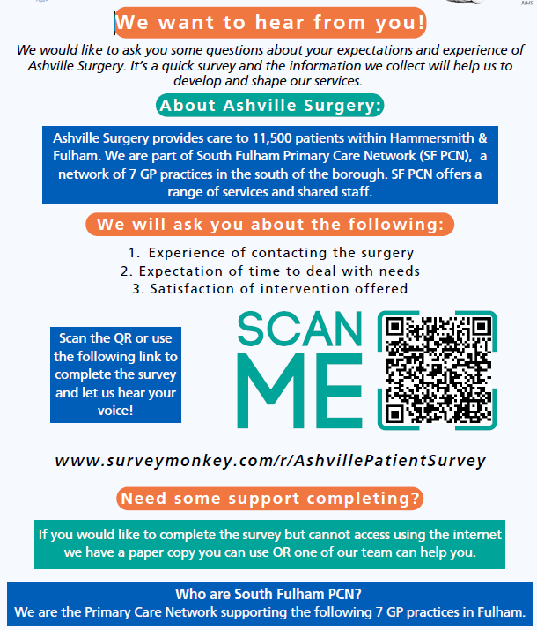

4 Surgery developments

* Ashville now has a new receptionist (Carolina).
* With a measles outbreak in the news, we are offering unvaccinated patients MMR vaccination
* We are getting a new phone system (imminently). This will allow for patients to be called back rather than wait in a queue. It will also allow us to have a ‘vulnerable’ patients list, who go to the front of the queue when they call. It will also integrate with our clinical system, which will make dealing with patient calls a lot more streamlined.

5 PCN developments

* A new Link worker (social prescriber) has recently joined the team.

6 Any other business

* Sandra asked about Charing Cross and Chelsea & Westminster hospitals access to practice records. Unfortunately, neither hospital do have full access to practice patient records, though slowly this is changing, with some information available (eg blood tests etc).
* Mody asked about the new Pharmacy First scheme. The practice is monitoring this closely. It could be a useful service if patients choose to use it.

*The new Pharmacy First Service will enable community pharmacists to complete episodes of care for patients without the need for the patient to visit their general practice. This, alongside expansions to the pharmacy blood pressure checking and contraception services, will save up to 10 million general practice team appointments a year and help patients access quicker and more convenient care, including the supply of appropriate medicines for minor illness.*

For more info: <https://www.england.nhs.uk/2024/02/nhs-campaign-to-help-patients-get-treatment-from-their-pharmacy/>

* PATCHs feedback. Mody mentioned that there are a lot of questions for patients to complete when submitting a PATCHs. He also pointed out that there is no option to go back into a PATCHs – once submitted – to cancel it (if circumstances have changed). MN said he would raise this with the PATCHs team who are receptive to feedback.

7 Date of next meetings

* Ashville PPG – to be confirmed